# Ryan Timbrook

## IST 659 Data Admin Concepts &Db Mgmt

## Date: 8/13/18

## Lab Assignment: Lab 5, Physical Design and DDL

## Description / Learning Objective

* Demonstrate data definition language (DDL) proficiency
* Demonstrate ability to convert from diagrams to SQL code

## Responses:

### Part 1, Creating Tables

TODO-1: *Take a screenshot of your Object Explorer with your table and its columns and keys expanded. Paste this screenshot into your answer doc labeled as “User Table”*

## User Table

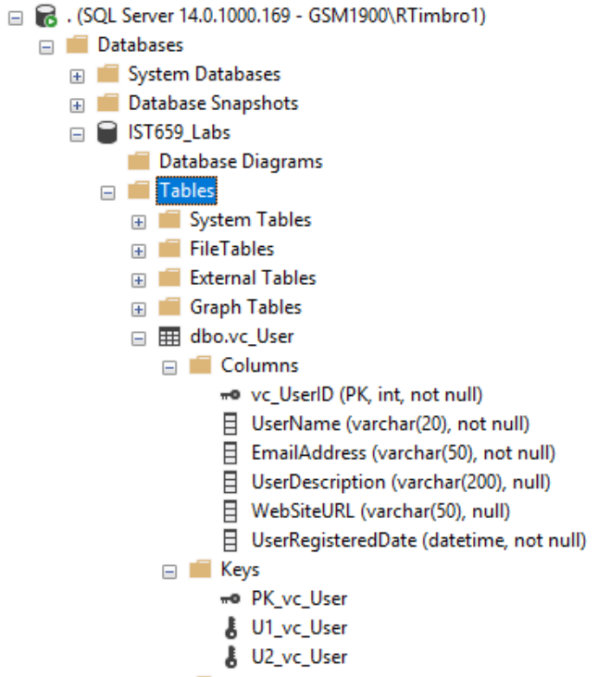

TODO-2: *Take a screenshot of your Object Explorer with your vc_UserLogin table and its columns and keys expanded. Paste this screenshot into your answer doc labeled as “User Login Table”*

## User Login Table

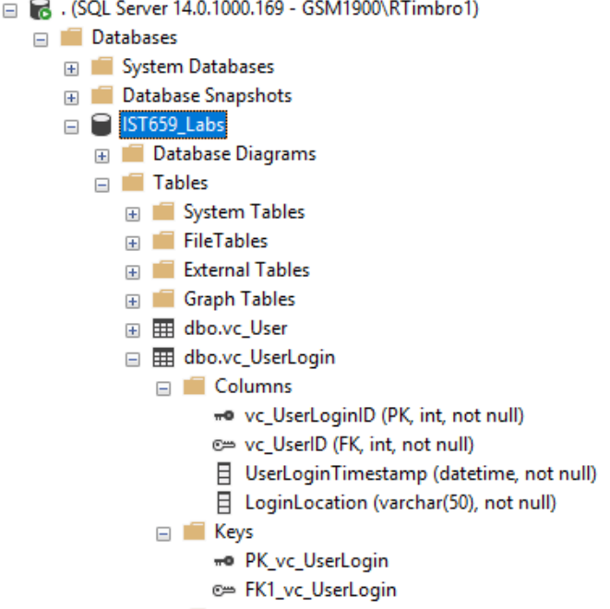

TODO-3: *Take a screenshot of your results grid and paste it into your answer document. Label it “User records”*

## User Records

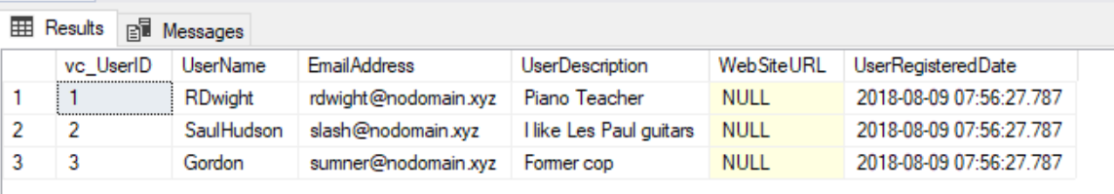

TODO-4: *In the Object Explorer, refresh your Tables folder and take a screenshot of this portion of the screen. Paste it into your answers document and label it “Follower List”*

## Follower List

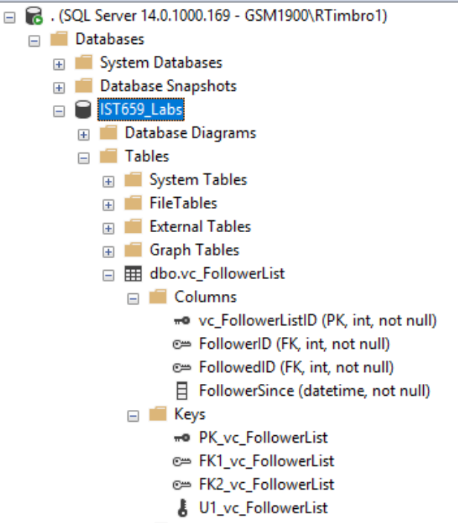

### Part 2, The Rest of the Tables

*Code and execute the SQL CREATE TABLE statements to create the remaining tables.*

TODO-1: *Refresh your Tables folder in the Object Explorer and take a screenshot of the listing as before. Paste this screenshot into your answers document labeled “VidCast tables”*

## VidCast Tables

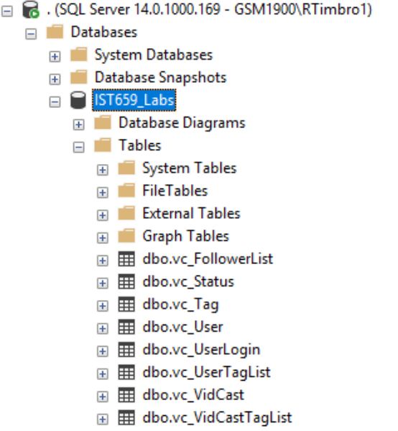

TODO-2: *After completing Part 2, copy and paste the text of your SQL query file at the end of your answers document. Save this document and submit it to the appropriate section on the LMS.*

*SQL Query*

|  |
| --- |
| /*  Author: Ryan Timbrook  Course: IST 659 Data Admin Concepts & Db Mgmt  Term: Summer, 2018  */  -- Creating the User Table  Create Table vc_User(  -- Columns for the User Table  vc_UserID int identity,  UserName varchar(20) not null,  EmailAddress varchar(50) not null,  UserDescription varchar(200),  WebSiteURL varchar(50),  UserRegisteredDate datetime not null default GetDate(),  -- Constraints on the User Table  CONSTRAINT PK_vc_User PRIMARY KEY(vc_UserID),  CONSTRAINT U1_vc_User UNIQUE(UserName),  CONSTRAINT U2_vc_User UNIQUE(EmailAddress)  )  -- End Creating the User Table  -- Creating the UserLogin Table  Create Table vc_UserLogin(  -- Columns for the UserLogin table  vc_UserLoginID int identity,  vc_UserID int not null,  UserLoginTimestamp datetime not null default GetDate(),  LoginLocation varchar(50) not null,  -- Constraints for the UserLogin table  CONSTRAINT PK_vc_UserLogin PRIMARY KEY(vc_UserLoginID),  CONSTRAINT FK1_vc_UserLogin FOREIGN KEY(vc_UserID) REFERENCES vc_User(vc_UserID)  )  -- End Creating the UserLogin Table  -- Adding Data to the User Table  INSERT INTO vc_User(UserName, EmailAddress, UserDescription)  VALUES  ('RDwight','rdwight@nodomain.xyz','Piano Teacher'),  ('SaulHudson','slash@nodomain.xyz','I like Les Paul guitars'),  ('Gordon','sumner@nodomain.xyz','Former cop')  SELECT * from vc_User  -- End adding data to the User Table  -- Creating the follower List Table  CREATE TABLE vc_FollowerList(  -- Columns for the follower List Table  vc_FollowerListID int identity,  FollowerID int not null,  FollowedID int not null,  FollowerSince datetime not null,  -- Constraints on the Follower List Table  CONSTRAINT PK_vc_FollowerList PRIMARY KEY(vc_FollowerListID),  CONSTRAINT U1_vc_FollowerList UNIQUE(FollowerID, FollowedID),  CONSTRAINT FK1_vc_FollowerList FOREIGN KEY(FollowerID) REFERENCES vc_User(vc_UserID),  CONSTRAINT FK2_vc_FollowerList FOREIGN KEY(FollowedID) REFERENCES vc_User(vc_UserID)  )  -- End Creating the follower List Table  -- Creating the following Tag Table  -- Order: 1  CREATE TABLE vc_Tag(  -- Columns for the follower List Table  vc_TagID int identity,  TagText varchar(20),  TagDescription varchar(100),  -- Constraints on the Follower List Table  CONSTRAINT PK_vc_TagID PRIMARY KEY(vc_TagID),  CONSTRAINT U1_TagText UNIQUE(TagText)  )  -- End Creating the Tag Table  -- Creating the following Status Table  -- Order: 2  CREATE TABLE vc_Status(  -- Columns for the follower List Table  vc_StatusID int identity,  StatusText varchar(20),  -- Constraints on the Follower List Table  CONSTRAINT PK_vc_StatusID PRIMARY KEY(vc_StatusID),  CONSTRAINT U1_StatusText UNIQUE(StatusText)  )  -- End Creating the Status Table  -- Creating the following VidCast Table  -- Order: 3  CREATE TABLE vc_VidCast(  -- Columns for the follower List Table  vc_VidCastID int identity,  VidCastTitle varchar(50),  StartDateTime datetime,  EndDateTime datetime,  ScheduledDurationMinutes int,  RecordingURL varchar(50),  vc_UserID int,  vc_StatusID int,  -- Constraints on the Follower List Table  CONSTRAINT PK_vc_VidCastID PRIMARY KEY(vc_VidCastID),  CONSTRAINT FK1_vc_UserID FOREIGN KEY(vc_UserID) REFERENCES vc_User(vc_UserID),  CONSTRAINT FK2_vc_StatusID FOREIGN KEY(vc_StatusID) REFERENCES vc_Status(vc_StatusID)  )  -- End Creating the VidCast Table  -- Creating the following VidCastTagList  -- Order: 4  CREATE TABLE vc_VidCastTagList(  -- Columns for the follower List Table  vc_VidCastTagList int identity,  vc_TagID int,  vc_VidCastID int  -- Constraints on the Follower List Table  CONSTRAINT PK_vc_VidCastTagList PRIMARY KEY(vc_VidCastTagList),  CONSTRAINT FK1_vc_TagID FOREIGN KEY(vc_TagID) REFERENCES vc_Tag(vc_TagID),  CONSTRAINT U1_vc_TagID UNIQUE(vc_TagID), --ARE THESE UNIQUE DECLARATIONS NEEDED? FKs should enforce this?  CONSTRAINT FK2_vc_VidCastID FOREIGN KEY(vc_VidCastID) REFERENCES vc_VidCast(vc_VidCastID),  CONSTRAINT U2_vc_VidCastID UNIQUE(vc_VidCastID) --ARE THESE UNIQUE DECLARATIONS NEEDED? FKs should enforce this?  )  -- End Creating the VidCastTagList  -- Creating the following UserTagList Table  -- Order: 5  CREATE TABLE vc_UserTagList(  -- Columns for the follower List Table  vc_UserTagListID int identity,  vc_TagID int,  vc_UserID int,  -- Constraints on the Follower List Table  CONSTRAINT PK_vc_UserTagListID PRIMARY KEY(vc_UserTagListID),  CONSTRAINT FK1_vc_UserTagList_TagID FOREIGN KEY(vc_TagID) REFERENCES vc_Tag(vc_TagID),  CONSTRAINT U1_vc_UserTagList_TagID UNIQUE(vc_TagID),  CONSTRAINT FK2_vc_UserTagList_UserID FOREIGN KEY(vc_UserID) REFERENCES vc_User(vc_UserID),  CONSTRAINT U2_vc_UserTagList_UserID UNIQUE(vc_UserID)  )  -- End Creating the UserTagList Table |